**TI BYTE Simulation Exercise**

**Week 6 : Op-Amps**

* **Question 1:**

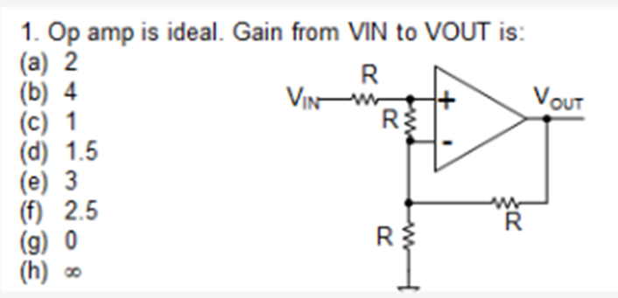

* **QUCS Circuit:**

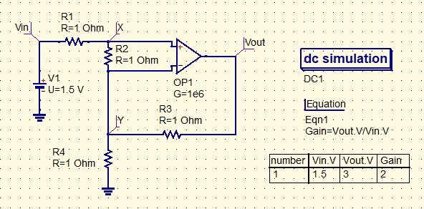

* **Vin is the input voltage given with an amplitude of 1.5 V.**
* **Vout is used to label the output node and find the voltage at that node.**
* **The Op-Amp is considered to be an ideal one, but since an ideal Op-amp is difficult to implement in QUCS, the gain is considered to be very high (~106), so that it behaves almost like an ideal one.**
* **QUCS Result:**

**Therefore, from the simulation, we get our answer as:**

**Thus, Gain = 2**

**Answer: (a)**

* **Conclusion:**
* **Since the Op-Amp is an ideal one and has infinite input impedance, no input current flows into the Op-Amp.**
* **Now, due to the presence of a negative feedback from the output of the Op-Amp to the inverting terminal of the Op-Amp, the voltage at the inverting and non-inverting terminal should be equal due to virtual short, i.e., Vx = Vy.**
* **Thus, there wouldn’t be any current flowing through the resistor R2, and thus it can be ignored. So, the circuit simplifies into just a non-inverting amplifier.**
* **Now, since no current flows into the Op-Amp, no current flows through R1. Thus, Vy = Vx = Vin = 1.5 V.**
* **So, current though R4, $I=\frac{V_{y}}{R_{4}}=\frac{1..5}{1}=1.5 A$**
* **Therefore, voltage at $V_{out}= V_{y}+ I×$ R3 $=1.5+1.5×1=3V$**
$Gain=\frac{V_{out}}{V_{in}}=\frac{3}{1.5}=2$

* **Thus, our answer is verified with the simulated result.**
* **Question 2:**

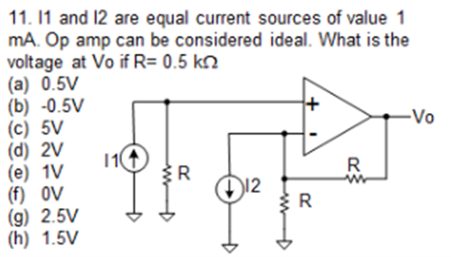

* + **QUCS Circuit:**

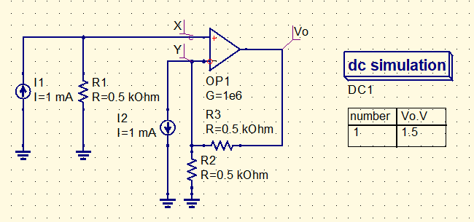

* **The circuit has two current sources I1 and I2, both of value 1 mA.**
* **Vout is used to label the output node and find the voltage at that node.**
* **The Op-Amp is considered to be an ideal one, but since an ideal Op-amp is difficult to implement in QUCS, the gain is considered to be very high (~106), so that it behaves almost like an ideal one.**
* **QUCS Result:**

**Therefore, from the simulation, we get our answer as:**

**Thus, Vo = 1.5 V**

**Answer: (h)**

* **Conclusion:**
* **Since the Op-Amp is an ideal one having infinite input impedance, no current can flow through it.**
* **Therefore, the current I1 flows totally through R1, causing the voltage at node X to be, Vx = I1R1 = 0.5 V**
* **D due to the presence of a negative feedback from the output of the Op-Amp to the inverting terminal of the Op-Amp, the voltage at the inverting and non-inverting terminal should be equal due to virtual short, i.e., Vx = Vy = 0.5V**
* **Now, current through resistor R2, $I_{3}= \frac{V_{y}}{R_{2}}= \frac{0.5}{0.5k}= 1 mA$**
* **So, current flowing through R3, $I=I_{2}+ I_{3}=2 mA$**
* **Then, $V_{out}=V_{y}+ I×R_{3}=0.5 V+2 mA × 0.5kΩ=1.5 V$**
* **From the simulation, we got the same result, thus our answer is correct and verified.**